 Results Information

28044 James Dr. Customer ID: Roger Spurr
Warren, MI Project #: P-234
48092 Sample Date Received: 6/20/15
Phone: 586-806-4243 Date of Testing/Analysis: 7/1/15 - 9/17/15
Fax: 313- 577-8616 Sample Type: 3 mud fossil samples
Email: info@helixbiolab.com Analysis Type: DNA Extraction, PCR,
DNA Sequencing and Analysis

Objective:

The objective of this analysis is to perform extraction of genomic and/or mitochondrial DNA from three mud fossil samples. Upon successful DNA extraction from the samples, subsequent analysis will include the amplification of extracted DNA using the PCR technique targeting specific DNA marker sequences and to obtain DNA sequence from the amplified PCR products.

Mud fossil samples analyzed had the following designations:
36 inch tip
Lung
Mud Tip

Procedure:

DNA Extraction

Bacterial DNA was extracted from each of the three submitted mud fossil samples using the Gene Clean Ancient DNA Extract Kit (MP BIO, Solon, OH) according to the manufacturer's instructions. 50 microliters (ul) of proteinase K solution was added to each sample prior to incubation at 56°C and incubation was carried out for 24 hours to ensure complete lysis. A negative control sample was also included in the DNA extraction procedure. The DNA extraction from each sample was collected from the column in two elution steps such that the DNA extraction obtained from each sample consisted of a "first" and "second" elution. Following the DNA extraction procedure, the concentration and optical density of each DNA extraction was measured using the nanodrop spectrophotometer. DNA concentration in nanograms (ng) per microliter (ul) and optical density of each of the three mud fossil samples is listed in the results section. The DNA extraction from each sample was then used as DNA template for qualitative PCR analysis.

PCR

Qualitative PCR analysis incorporated oligonucleotide primers that target specific marker DNA sequences found in the mitochondrial genome. Three sets of mitochondrial DNA specific primers were selected from the published literature (Alonso et al. 2003) and used in all PCR experiments performed. The three sets of mitochondrial DNA specific primers selected have previously been demonstrated to amplify short amplicons from the mitochondrial genome of approximately 100 base pairs (bp) from ancient DNA samples.

The PCR conditions used for all reactions followed the procedure established in Alonso el al. 2003: 95°C for 10 minutes followed by 36 cycles of 95°C, for 10 seconds, 60°C for 30 seconds, and 72°C for 30 seconds, followed by a final extension at 72°C.

All reactions involved one primer pair per reaction. In some instances, better quality amplification of the target mitochondrial DNA sequences was achieved using DNA from the second elution of the sample DNA extraction.

The negative control DNA extraction sample was included in all PCR experimentation. Following the PCR procedure, the PCR products were run on a 1.5% agarose gel at 90V for 70 minutes, after which the agarose gel containing the PCR products was visualized under UV light and examined for PCR amplification products that represent the amplification of the target DNA markers. The image of the agarose gel containing the PCR products is shown in the results section.

Results:

DNA Extractions

DNA was successfully extracted from each of the three samples (36 inch tip, lung and mud tip). The concentrations and optical densities of the DNA extractions are listed below

Sample Concentration Optical Concentration Optical
Name 1st Elution (ng/ul) Density 2nd Elution (ng/ul) Density

36 Inch Tip 135.1 1.91 43.5 2.55

Lung 299.8 1.62 172.7 1.55

Mud Tip 91.9 2.20 37.7 2.52

PCR

A positive PCR result for a specific mitochondrial DNA marker indicates that the marker DNA sequence was successfully amplified in the sample. A sample testing negative for a specific mitochondrial DNA marker indicates that the marker DNA sequence was not successfully amplified. In each of the samples that tested positive, one single amplicon of the correct size (as measured in base pairs) was amplified. These amplicons appear as one single distinct band on the agarose gel (see figure 1). Amplicons produced from primer pairs A1/A1R and 4F/4R were the most robust amplicons produced and as a result, these amplicons were selected for DNA sequencing.

Results of PCR using mitochondrial DNA primers A1/A1R described in Alonso et al. 2003

Sample Result
36 Inch Tip positive
Lung positive
Mud Tip positive
Negative Control negative

Results of PCR using mitochondrial DNA primers 2F/2R described in Alonso et al. 2003

Sample Result
36 Inch Tip positive
Lung positive
Mud Tip negative
Negative Control negative

Results of PCR using mitochondrial DNA primers 4F/4R described in Alonso et al. 2003

Sample Result
36 Inch Tip positive
Lung positive
Mud Tip negative
Negative Control negative

Figure 1
Agarose gel containing the products of the PCR amplification:
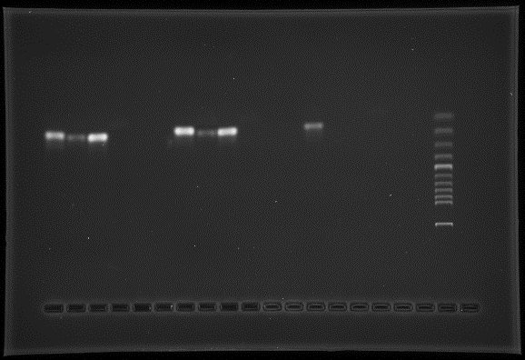

Lane Sample Primers "*" indicates PCR products that were
1 36 Inch Tip A1/A1R* used for DNA sequencing
2 36 Inch Tip 2F/2R
3 36 Inch Tip 4F/4R*
4 Negative Control A1/A1R
5 Blank
6 Blank
7 Lung A1/A1R*
8 Lung 2F/2R
9 Lung 4F/4R*
10 Negative Control 2F/2R
11 Blank
12 Blank
13 Mud Tip A1/A1R*
14 Mud Tip 2F/2R
15 Mud Tip 4F/4R
16 Negative Control 4F/4R
17 Blank
18 Blank
19 100 Base pair ladder
DNA Sequencing

PCR products were submitted to Eton Biosciences Inc. (Union New Jersey) for DNA sequencing. The primer pairs A1/A1R and 4F/4R that were used to generate the PCR products were also used in DNA sequencing. Excellent quality DNA sequence was obtained for the 36 inch tip sample and for the lung sample using primers A1 and 4F (see chromatograms, figures 2 and 3). The quality of DNA sequence obtained for the 36 inch tip sample and for the lung sample was on average less using primers A1R and 4R.

Following the processing and formatting of the DNA sequence data, approximately 80 to 100 base pairs (bp) of DNA sequence generated for the 36 inch tip sample (using primers A1 and 4F) and for the lung sample (using primers A1 and 4F) were submitted individually into a nucleotide "BLAST" search, using the National Center for Biotechnology Information (NCBI) database, whereby each DNA sequence was matched to all DNA sequences contained in the NCBI DNA sequence database.

Results of the BLAST search using DNA sequences generated from the 36 inch tip and lung samples using mitochondrial DNA primers A1 and 4F:

Sample Primer Sequence Match
36 inch tip A1 Homo sapiens Mitochondrial Cytochrome b Gene

36 inch tip 4F Homo sapiens Mitochondrial D-Loop Region

Lung A1 Homo sapiens Mitochondrial Cytochrome b Gene

Lung 4F Homo sapiens Mitochondrial D-Loop Region

Figure 2
Chromatograms of DNA Sequences Obtained for 36 Inch Tip Sample Using Primers A1 and 4F

Sample: 36 Inch Tip
Primer: A1

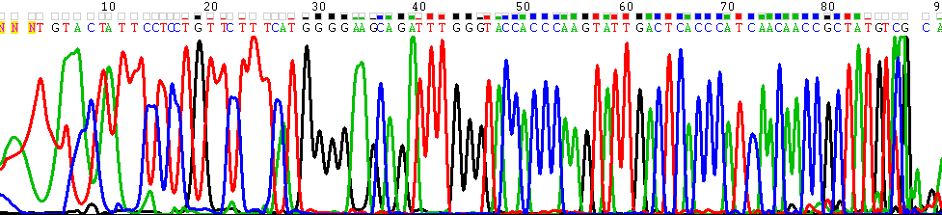

Sample: 36 Inch Tip
Primer: 4F
https://www.youtube.com/watch?v=nfdxxyT7Dco
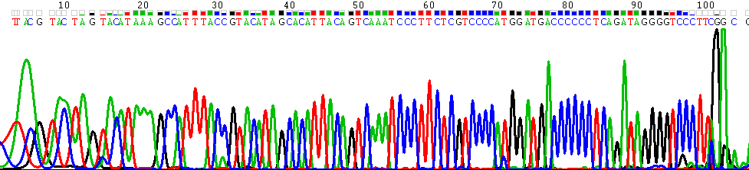

Figure 3
Chromatograms of DNA Sequences Obtained for the Lung Sample Using Primers A1 and 4F

Sample: Lung
Primer: A1

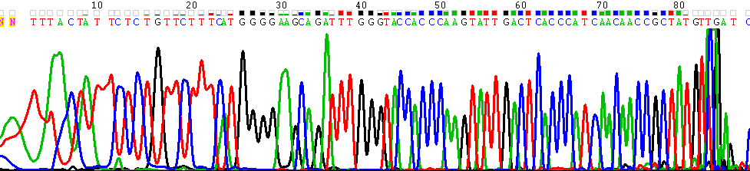

Sample: 36 Inch Tip
Primer: 4F

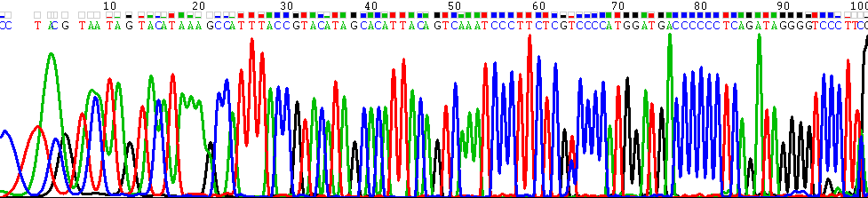

These results were verified by Tom Prychitko, Laboratory Director for Helix Biological Laboratory.

